 | EUROPEAN COMMISSION  DIRECTORATE-GENERAL  INFORMATICS  Infrastructure and Logistics Directorate  Technical solutions and office systems | 

European Commission
E-TrustEx Adapter Interfacepplet Architecture

Date: | 13/10/2014
Version: | 1.7
Authors: | Valer Micle
Revised by: | Olivier Touly
Approved by:

Contents
- 1. Introduction 4
1.1. Purpose 4
1.2. Scope 4
1.3. Context 4
1.4. Audience 4
- 2. Architecture requirements 4
2.1. Overview of the key objectives 4
2.2. Use cases 4
2.3. Nonfunctional requirements 5
2.4. Risks 5
- 3. Behavioral views 5
3.1. Uploading attachments 5
3.1.1. Uploading steps: 6
3.1.2. Implementation issues 7
3.2. Downloading attachments 7
3.2.1. Downloading steps 7
3.2.2. Implementation issues 8
3.3. Encrypting/decrypting attachments 8
3.3.1. Context 8
3.3.2. Encrypting attachments 8
3.3.3. Decrypting attachments 9
3.3.4. Implementation considerations 10
- 4. Security 11
4.1. Point to Point (Applet - NODE) 11
4.1.1. Authentication 11
4.1.2. Authorization and Integrity 11
4.1.3. Encryption 11
4.2. End-to-End (Applet - EDMA) integrity – Digital Signature 11

Document History

Version | Date | Comment | Modified Pages
1.0 | 30/04/2012 | Creation
1.1 | 09/05/2012 | Added the encryption-decryption-signature details | 8-11
1.2 | 14/05/2012 | Specify the validation of the message bundle signature and provide the context for encryption/decryption | 8, 9, 11
1.3 | 24/05/2012 | Update the communication mechanism between the applet and the node (use direct call). Update the policy for signing/validating the message bundle for point to point integrity | 8- 11
1.4 | 30/05/2012 | Specify that the payload XML needs to be created before starting uploading the attachment files | 6
1.5 | 14/06/2012 | Update the terminology, improve the clarity of the diagrams, send the payload XML not encrypted and put the AES256 SessionKey part of the document wrapper | 6, 7, 8, 9, 10, 12
1.6 | 22/06/2012 | - Remove the retrieve ICA service from the Applet and have it taken as an input parameter from the web  - the development view was added | 8, 9, 12-18
1.7 | 13/10/2014 | Remove the development view as it is not up to date anymore and we don’t plan on updating the document all the time the view is going to change

Introduction

Purpose
The purpose of this document is to provide an architecture overview of the applet from upload/download perspective. It is intended to describe the different possible interactions from the applet and describes the architectural decisions that have been made for it

Scope
The scope of this document covers the applet upload/download interactions for the WEB e-TrustEx system ONLY.

Context
The upload functionality happens on the context of sending new messages with attachments. In this context, the applet will have the functionality of uploading the attachments to the storage server.
The download applet takes place on the context of reading messages with attachments. Here, it will display all the files available for download, making possible for the user to select what files he wants to download.

Audience
The target audience of this document is the development team in charge of e-TrustEx WEB System and other persons familiar with the e-TrustEx project willing to have details about the upload/download feature.

Architecture requirements
This section describes the set of requirements driving the design of the applet architecture

Overview of the key objectives
The first objective of the applet architecture is to provide the details to support the implementation of uploading and downloading files via an applet. This must offer:
- Interaction with the client’s file system for selecting files to upload and selecting output folder for download
- A web-service client implementation for uploading/downloading files to the NODE and sending the message bundle to the NODE
- A remote control API for controlling the applet via JavaScript

The second objective is to scale so that it can support uploading of large number of files (up to 500) each of them having up to 100 MB without putting a considerable stress on the client machine where the applet will run.

Use cases
Two basic use-cases exist at this stage for the applet:
- Uploading files: multiple files of large size can be uploaded to the NODE
- Downloading files: multiple files can be downloaded directly from the NODE

Nonfunctional requirements
- Support of large files: The applet should support transfer of up to 100 MB files
- Support of group of files: The applet should support transferring up to 500 files in a group
- Confidentiality: The applet should ensure that the transferred files are not viewed by anybody else then the sender and the receiver
- Memory usage: The applet should use a predictable maximum amount of memory. As it runs in client side, the applet should be able to run with very low memory usage
- Permissions: The applet should have access to the local file system and be able to connect to remote web-services
- Availability: The applet should run on any web-browser. An automatic detection mechanism should be created in order to detect if the java plugin is installed and optionally to launch the installation process if needed.

Risks
The major risks associated with the design are as follows:
- Java plugin is disabled on client side
- Java Script is disabled on client side

In both situations a warning should be displayed to the user stating that the applet can work properly only if both (Java plugin and JavaScript) are enabled.

Behavioral views
In order to be able to interact with the user’s file system and to create connections to remote web-services, all the jars needed to run the applet should be signed.
Apache CXF has been chosen for implementing the web-service client using MTOM feature for efficiently transferring data.
The Applet implementation will be based on java 6.0 update 22 and is expected that browsers will have this java plugin-version or newer installed.

Uploading attachments
A sequence diagram for uploading the files to the NODE is shown in the next figure. Because the user can change its mind on what documents he wants to attach while he writes the message, the upload will be considered as an atomic operation and it will be bound to the send action. If the user will close the window while the upload is made, the upload process will be interrupted. The user should be warned about this and he should have the possibility to confirm if he closes the process or continues the upload.
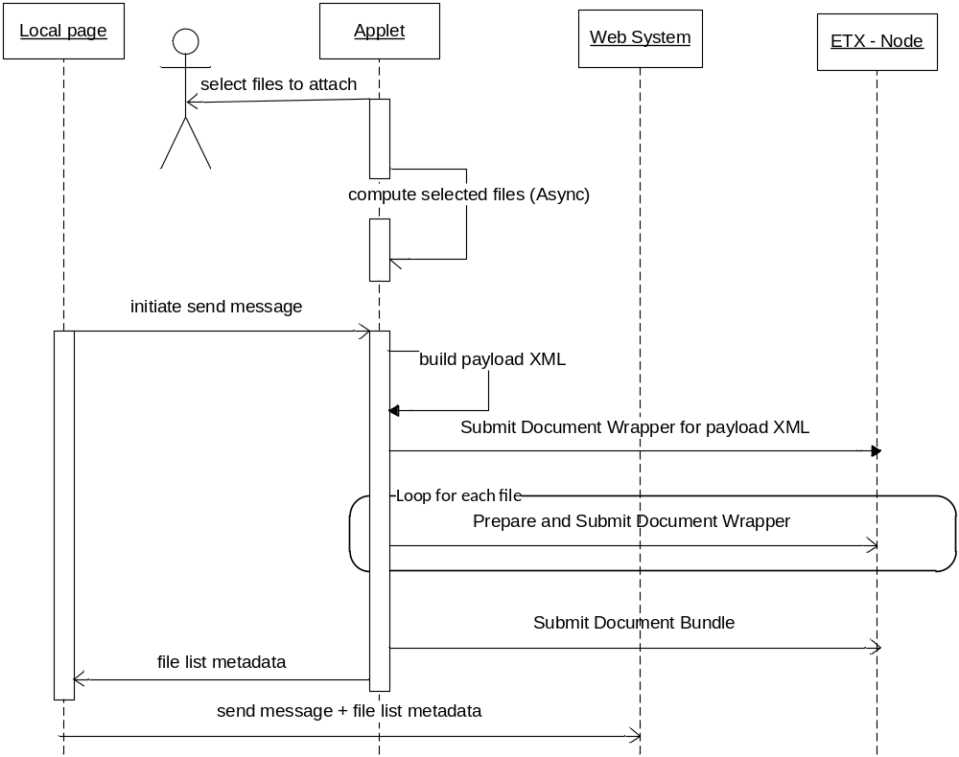

Uploading steps:
- Select files to attach: The user should be able to select files and folders from the files system in order to have them attached to a message.
- Compute selected files: An asynchronous process is started to display the selected files and all the files the selected folders/subfolders. A selection summary should be computed at the same time, showing the total number of selected files and total size. It is important that this will be executed in background in order not to block the UI while this computation is made.
- Initiate send message: When the send is initiated from UI, a JavaScript code will call the applet remotely to proceed with the upload.
- Build payload XML: Build the payload XML based on the UI data as a file in order to be uploaded with all the other attachments
- Submit Document Wrapper for payload XML: Submit the payload XML to the NODE via the Submit Document Wrapper service without encrypting it
- Prepare and Submit Document Wrapper: Proceed with preparing and submitting the document wrappers to the NODE for each of the files selected by the user. For complete details on the process of preparing and submitting the Document Wrapper to the NODE, please see section 3.3.2 Encrypting attachments. The communication with the NODE will be made via a web-service client using an SSL transport layer.
- Submit Document Bundle: Once all the files have been treated, submit the document bundle to the NODE
- Return File list metadata: Return the uploaded file list metadata to the web-page and write them in a placeholder
- Send message + File list metadata: Submit the message + the updated file list metadata to the WEB System. Once the applet finishes all the work, it will proceed with the submission of the web-page to the Web System server

Implementation issues
Implementation issues to consider:
- Threading: All time-consuming operations should be executed in a background process in order not to block the GUI
- Security: Please see the chapter dedicated to security for details.
- Performance: The applet should upload by default 4 files in parallel. For upload, MTOM should be used in order to send data efficiently. The chunk size for uploading should be 32KiB. The applet should give the possibility to overwrite these default values via parameter configurations.
- Reliability: The WEB System should keep the session alive during file uploading in order to be able to do the final submit. If a file fails to be uploaded, the applet should automatically try to resend it 2 times. If it fails after two times, the whole sending is considered as failed.
- Visibility: A progress bar will be displayed per file being uploaded and one progress bar for the total files being uploaded.

Downloading attachments
A sequence diagram for downloading files from the NODE is shown in the next figure. If the user will close the window while the download is made, the download process will be interrupted. The user should be warned about this and he should have the possibility to confirm if he closes the process or continues the download.
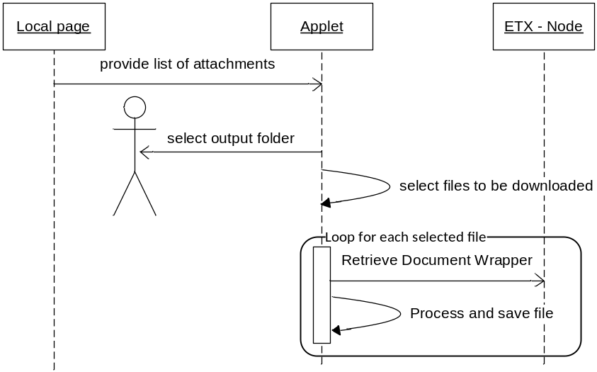

Downloading steps
- Read file list metadata: Since the applet starts after the page was loaded, the applet needs to read the list of files available for download from a temporarily location on the web-page
- Select output folder: Prior downloading any attachment, the user needs to select the output folder
- Select files to download: From the total list of files, select the files that needs to be downloaded
- Retrieve Document Wrapper: Retrieve the Document Wrappers corresponding to each selected file from the NODE. The communication with the NODE will be made via a web-service client using an SSL channel.
- Process and save file: Process a file if is encrypted. For details about this process, please check the section 3.3.3 Decrypting attachments. Once the processing is finished, save the file to the selected output location

Implementation issues
- Security: Please see the chapter dedicated to security for details.
- Performance: The applet should download by default 4 files in parallel. For download, MTOM should be used in order to receive data efficiently. The chunk size for download should be 32KiB. The applet should give the possibility to overwrite these default values via parameter configurations.
- Reliability: If a file fails to be downloaded, the applet should automatically try to re-download it 2 times. If it fails after two times, the file is considered failed to be downloaded. The whole download process should not be affected by a single download fail. Later retries should be possible
- Visibility: A progress bar will be displayed per file being downloaded and one progress bar for the total files being downloaded.

Encrypting/decrypting attachments
For performance reasons, all files will be encrypted/decrypted symmetrically with AES256 and only the AES 256 key will be encrypted/decrypted asymmetrically. The encrypted symmetric keys will be sent part of the DocumentWrapper.

Context
Each user willing to use Web System for communicating with a Back Office application, will providing the public certificate to the NODE part of the Party Registration Process. From this moment, the public certificate is available on the NODE for download and it should be this certificate used all the time during the encryption/decryption process.

Encrypting attachments
The PublicKey used for encryption will be provided by the NODE via the "RetrieveInterchangeAgreement" service on the Web side. The Interchange Agreement together with the public key will be given as an input parameter to the applet.
For accessing the key store, DIGIT B1 will support the PKCS#12 file format. The certificate format must be a X509 certificate.
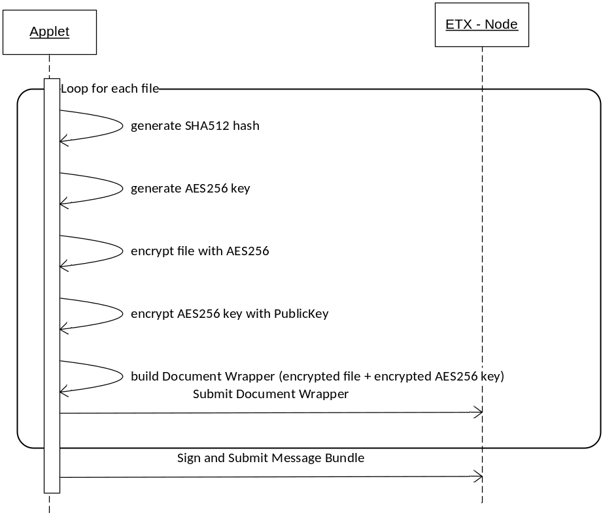

Uploading encrypted attachment steps:
- Generate the SHA512 for the unencrypted file and set it in the Message Bundle
- Generate the AES256 key to be used for encrypting one file
- Encrypt the file with AES256 using the above generated key
- Encrypt the generated AES256 key with the PublicKey
- Build the Document Wrapper containing the encrypted file and the encrypted AES256 key
- Submit the Document Wrapper to the NODE
- Sign and upload the message bundle to the node

Decrypting attachments
The decryption should be performed using AES256/CBC/PKCS7Padding. The encrypted symmetric keys are sent part of the DocumentBundle.
The user must provide the file containing the certificate to be used for decryption plus the password for accessing the certificate.
For accessing the file containing the certificates, DIGIT B1 will support the PKCS#12 file format. The certificate format must be a X509 certificate.

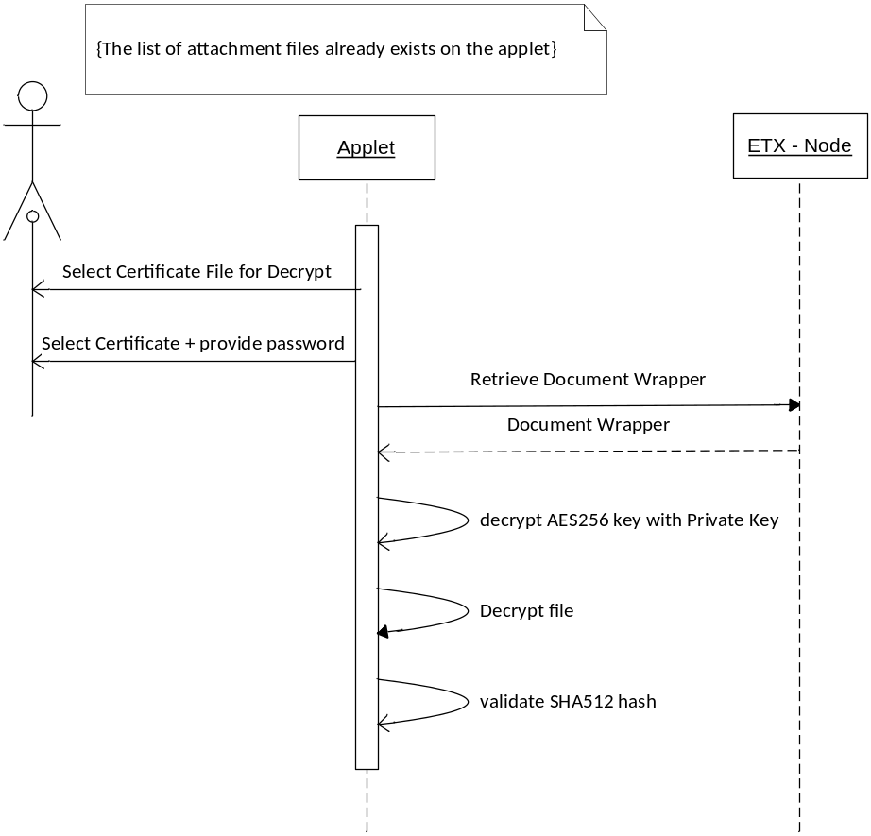
It is expected that the all the information needed to download the files is already in the applet.
Downloading and decrypt attachments steps:
- The user first selects the file containing the certificate file. This file must be a PKCS#12 format file
- The user selects the certificate to be used for decryption and provides the password for accessing this certificate. The certificate must be a X.509 certificate
- The Document Wrapper is downloaded from NODE containing the encrypted file and the encrypted AES256 key
- With the private key of the user, the AES256 key is decrypted
- With the AES256 symmetric key, the file is decrypted
- The SHA512 is computed for the decrypted file and verified that is the same as the one from the MessageBundle

Implementation considerations
- The security provider used for performing the Symmetric encryption/decryption is BouncyCastle.
- The algorithm used to encrypt the attachments is AES with a 256 bit key size with CBC (cipher block chaining) block mode and with PKCS7 padding.
- Use directly the BouncyCastle direct API in order to avoid the need of installing the unlimited-strength encryption policy file on each client machine where the Applet will perform the encryption/decryption and to be able to use AES with a 256 key size

Security

Point to Point (Applet - NODE)
All the communication between the Applet and the Web System must be executed in the context of ECAS authentication. As such, only user authenticated to the Web System via ECAS will have access to the Applet and all the parameters sent to the Applet will be secured by ECAS.

Authentication
The username and password required to connect to the NODE are sent from the Web System as a parameter to the Applet. The sending of these parameters is secured by ECAS

Authorization and Integrity
Pre-requirements: A System certificate is configured for the Web application by DIGIT. The Private Key is stored in the Web System and the Public Key is stored on the NODE.
The authorization is made based on digital signature. Only signed message will be accepted by the NODE.
The signing steps
- For the receiver party, in the ECAS authenticated context, dynamically generate a certificate every time the Applet is loaded. The certificate is generated with the receiver party and with the ECAS authenticated user-name part of the certificate fields for tracking purposes
- Send the Public Key of the generated certificate to the Web System for signing
- Web System signs the Public Key of the generated certificate with the Web System Certificate and returns the signed Public Key to the Applet
- The Applet computes the hash of the payload and includes in the technical header. With the Private Key of the generated certificate, the Applet signs the message header as a whole and sends the message to the NODE
- The NODE validates the signature against the Public Key of the Web System Certificate. If the certificate used for signing the message was signed by the Web System Certificate, the NODE will trust this certificate

Encryption
All the communication between the Applet and the NODE is made via an SSL channel which provides the encryption of the data sent over the channel. The SSL certificate will be passed to the Applet as a parameter from the Web System.

End-to-End (Applet - EDMA) integrity – Digital Signature
In order to ensure end to end integrity, The DocumentBundle will be signed with the client's certificate. For selecting the certificate, the user will provide the path to the file containing the certificate and it will provide the password to access the certificate.
NOTE: It falls into the responsibility of the user to obtain and provide the certificate for signing the message. If the user does not want to sign a message, a warning must be provided to the user.
DIGIT B1 supports PKCS#12 file formats for accessing the certificate used for signature.
The certificate must be a X.509 certificate.
As per DIGIT B4 suggestion, the signature must be XAdES-BES signature form (see e-TrustEx Supplementary Specification for Data Integrity document).

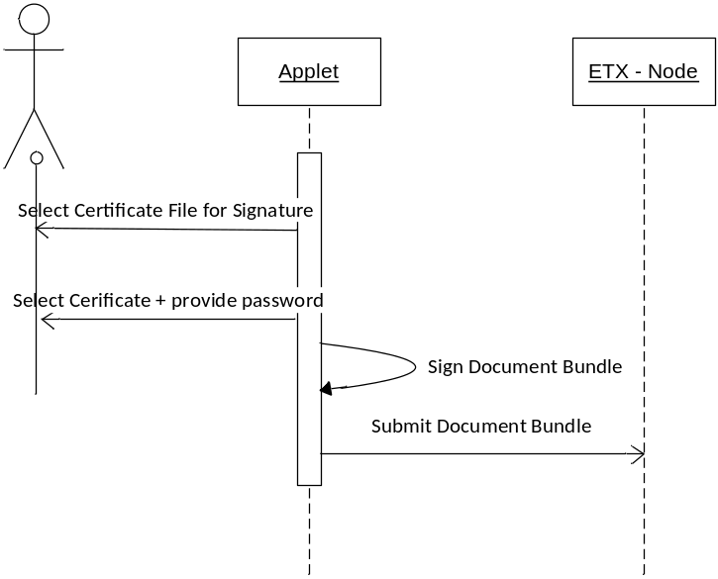
Signing Message Bundle steps
- The user selects the file containing the certificates used for signature. The file format must be PKCS#12
- Use user selects the certificate and provides the password for accessing the certificate. The certificate format must be X.509
- The MessageBundle is signed using the XAdES-BES signature profile. The used signature implementation provider will be XAdES4J (see here)
- The signed message bundle is submitted to the NODE

When the Web System receives a message bundle, it extracts the subject and the recipients from the bundle in order to be able to display the message in the message list before validating the signature.
When the user selects to open a message, the signature of the message bundle is validated. In case that the certificate used for signing the message bundle is not a trusted certificate, a warning will be displayed to the user.

